**Property Management Application Using Salesforce - (Developer) – ( Long-Term)**

ID:  LTVIP2024TMID11592

**Team leader:** N.INDHUMATHI

**Team member:**S.Aswini

**Fields**

When we talk about Salesforce, Fields represent the data stored in the columns of a relational database. It can also hold any valuable information that you require for a specific object. Hence, the overall searching, deletion, and editing of the records become simpler and quicker.  
  
1.Types of Fields  
2.Standard Fields  
3.Custom Fields  
  
**Standard Fields:**  
As the name suggests, the Standard Fields are the predefined fields in Salesforce that perform a standard task. The main point is that you can’t simply delete a Standard Field until it is a non- required standard field. Otherwise, users have the option to delete them at any point fromthe application freely. Moreover, we have some fields that you will find common in every Salesforce application. They are,  
1.Created By  
2.Owner  
3.Last Modified  
  
**Custom Fields:**  
On the other side of the coin, Custom Fields are highly flexible, and users can change them according to requirements. Moreover, each organizer or company can use them if necessary. It means you need not always include them in the records, unlike Standard fields. Hence, the final decision depends on the user, and he can add/remove Custom Fields of any given form.

**Create Fields**

1. Go to setup ? click on Object Manager ? type object name in search bar ? click on the object  
   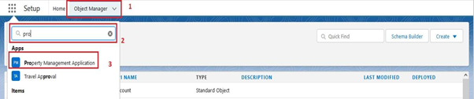  
     
   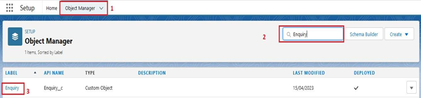  
     
   2.Now click on “Fields & Relationships” ? New.  
     
      
   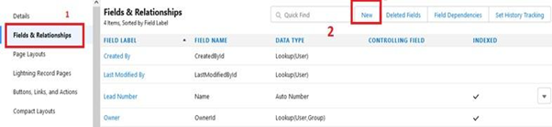  
   Select Datatype (Auto number)   
     
   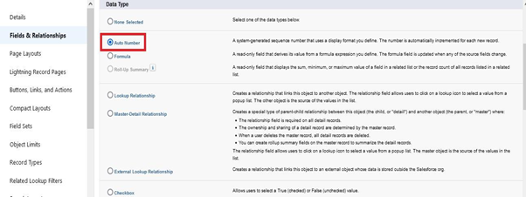  
     
   3. Fill the field label name Lead Number, Datatype (autonumber) ? Next ? Next ? Save.  
     
     
   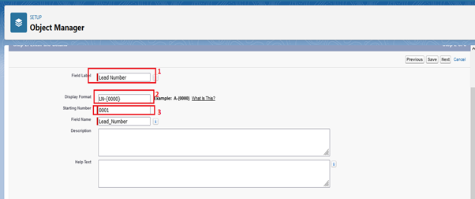  
     
   Create the remaining Fields:  
     
   Follow the above activity 1 Steps 1 to 2, create the Field just change the Labels and data types for Below Fields  
     
   Lead Type: Create the picklist fields by the values (Buy, Rent) State: Create the Picklist Fields (Maharashtra, Gujarat, Rajasthan) City: Create the Picklist Fields (Nashik, Surat, Jaipur)  
   Email: Create the Email Select the Data Type as Email (Email)  
   Phone: Select the Field Data type as (Phone)

**Create Picklist Field On Enquiry Object**

Create picklist fields on enquiry object

1. Click on the gear icon and then select Setup.
2. Click on the object manager tab just beside the home tab.
3. After the above steps, Select enquiry Object

Now Select Fields and relationships from setup menu of the enquiry object.

1. Click new and select Picklist fields ????next and enter label name(State) and select enter values option((Maharashtra, Gujarat, Rajasthan),next and Save
2. Note: we create picklist fields for city follow the above steps just change the Labels and values.

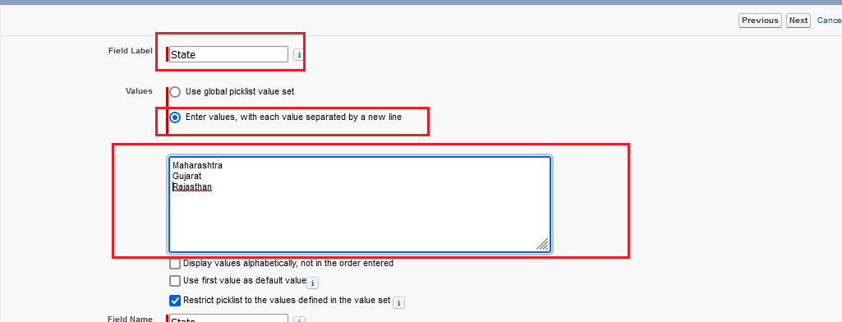

Create Field Dependency(on enquiry objects)

1. Create a dependency between these two picklists, so that when a state is selected, only respective Values are available.
2. The below steps will assist you in creating Field Dependencies.
3. Click on the gear icon and then select Setup.
4. Click on the object manager tab just beside the home tab.
5. After the above steps, Select enquiry Object
6. Now Select Fields and relationships from setup menu of the enquiry object.
7. Click Field Dependencies.
8. Click New.
9. Select State as the Controlling Field and select City as the Dependent Field.
10. Click Continue.
11. Select the appropriate Value in each column by double-clicking them.
12. Maharashtra:i) Nashik
13. Click Include Values. And it is also same for Gujarat & Rajasthan with its city.
14. Click Preview, then test the dependency by selecting different State and viewing the associate Values available for Particular state.
15. Click Close to close the preview window.
16. Click Save.

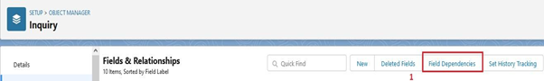

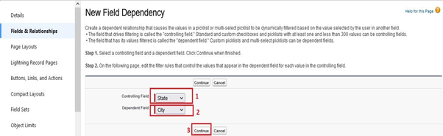

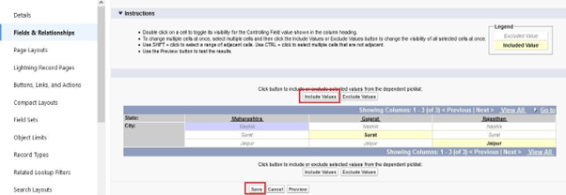

**For Property Object**

Create the remaining Fields:  
  
Follow the above activity 1 Steps 1 to 2, create the Field just change the Labels and data types for Below Fields.  
  
1.Customer name (lookup relationship related to Enquiry)  
2.Create Property Type: (Picklist fields) (Residential, Commercial, Industrial) (Field Dependency)  
3.Residential: Picklist fields (1BHK, 2BHK, 3BHK) (Field Dependency)  
4.Commercial: Picklist fields (Shop, Office) (Field Dependency)  
5.Industrial: Picklist fields (Factory, Mall) (Field Dependency)  
  
Note: In above picklist fields Property type is control field and Residential, Commercial, Industrial is dependent field  
  
  
6.State: Create the Picklist Field (Maharashtra, Gujarat, Rajasthan)(Field Dependency)  
7.City:(Take Any City for Field Dependency)  
  
Note: In above picklist fields State is a control fields and city is dependent field  
  
8.Discount:(Percentage As the Field Data Type)  
9.Price: (Number As the Field Data Type)  
10.Loan Amount: (Currency As the Field Data Type)  
  
For the Property Object? Go to the fields and Relationship and select the formula in field data type. In Formula option select Advanced Formula and write the followingformula.  
Lead_Id r.Customer_Name   c  
  
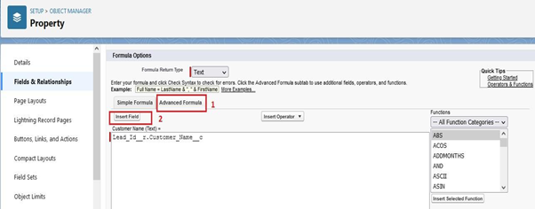

**For Loan Object**

Create the remaining Fields:  
Follow the above activity 1 Steps 1 to 2, create the Field just change the Labels and data types for   
Below Fields  
1. Property name: (lookup relationship related to property)  
2. Customer name: (lookup relationship related to Enquiry)  
3. Interest Rate: (Select the Field Data Type As Currency)  
4. Term: (Select the Field Data type as Number)  
5. Annual Loan: Field create the Number as the field data type  
6. Total Loan Installments: ( Field create the Number as the field data type)  
7. Loan Repayment: ( Field create the Number as the field data type)  
8. Loan Amount: (Select the Field data type as Formula)  
For the Loan Object? Go to the fields and Relationship and select the formula in  
field data type. In Formula option select Advanced Formula and write the following  
formula  
(Loan_Repayment__c* (((1+( Interest_Rate__c/52))^ Term__c) -1))/((   
Interest_Rate__c/52)*((1+( Interest_Rate__c/52))^ Term__c))  
##Check the syntax below whether the formula syntax is correct or not  
  
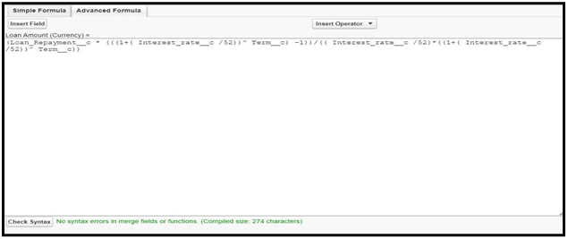

**Page Layout And Record Type**

Page Layout in Salesforce allows us to customize the design and organization of detail and edit pages of records in Salesforce. Page layouts can be used to control the appearance of fields, related lists, and custom links on standard and custom object detail and edit pages.

Record types in Salesforce allow you to have different business processes, picklist values, and page layouts to different users based on profile.

**Create Page Layout For Property Object**

Create a page layout for Property Object  
  
  
Go to setup ? click on Object Manager ? type object name in search bar ? click on the object  
Now click on “Page Layout” ? New.

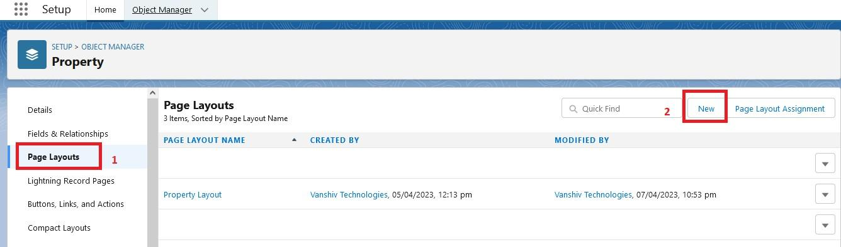

We can add or remove the the page layout field with the help of drag and drop

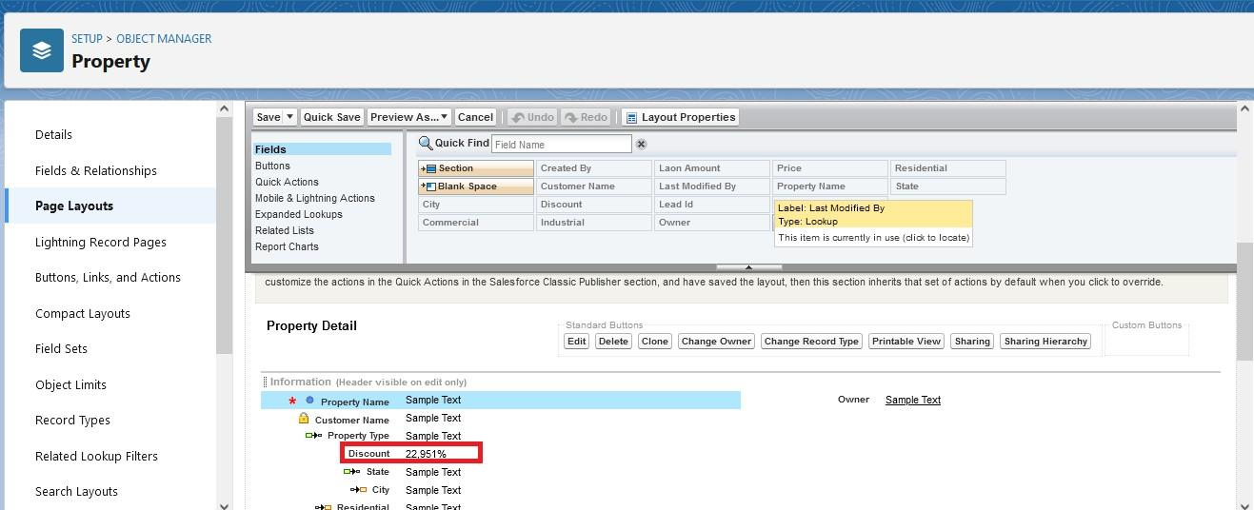

**Rent Page Layout**

Create another page layout name as (Rent) with the help of above steps of activity 1. And remove the discount and loan amount fields from the rent page layout

**Record Type For Property Object**

Go to setup ? click on Object Manager ? type object name in search bar ? click on the object  
Now click on “Record type ” ? New.

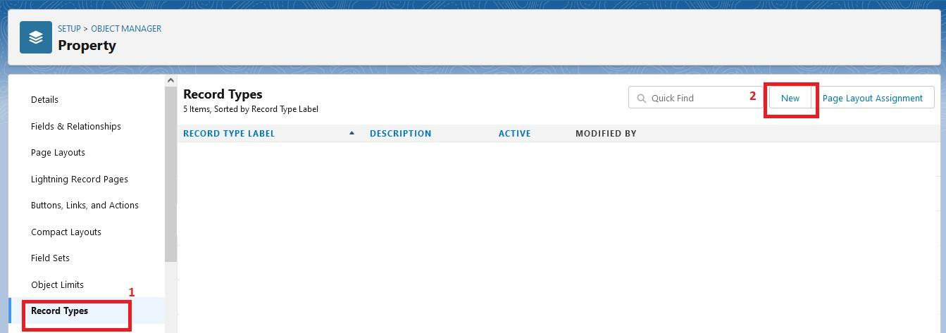

Enter the record type label as (Buy) and selective active checkbox next and save

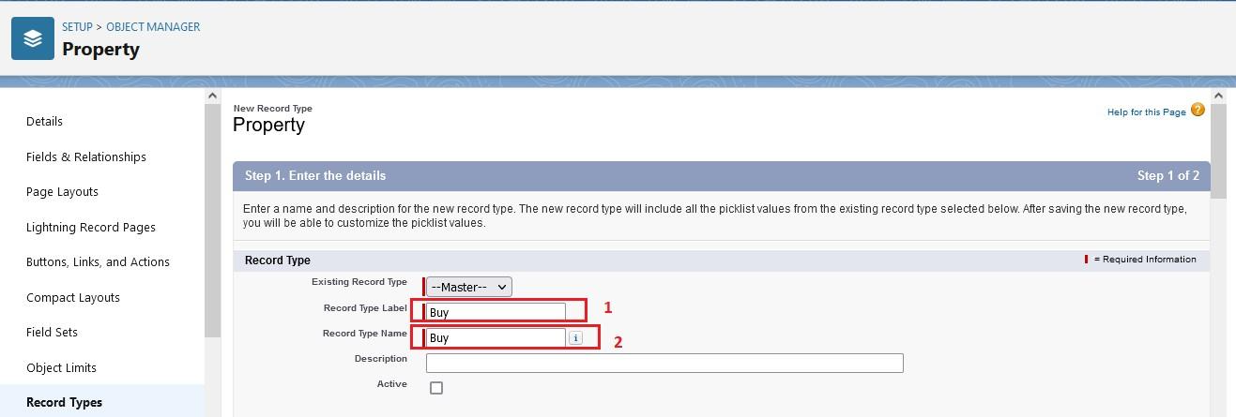

**Record Type Rent**

Create report type name has Rent with the above steps of activity-3

**Page Layout Assignment**

1. Go to setup ? click on Object Manager ? type object name in search bar ? click on the object
2. Now click on “page layout ” ? click page layout assignment
3. Select the buy record type and select page layout to use(buy) then click on save.

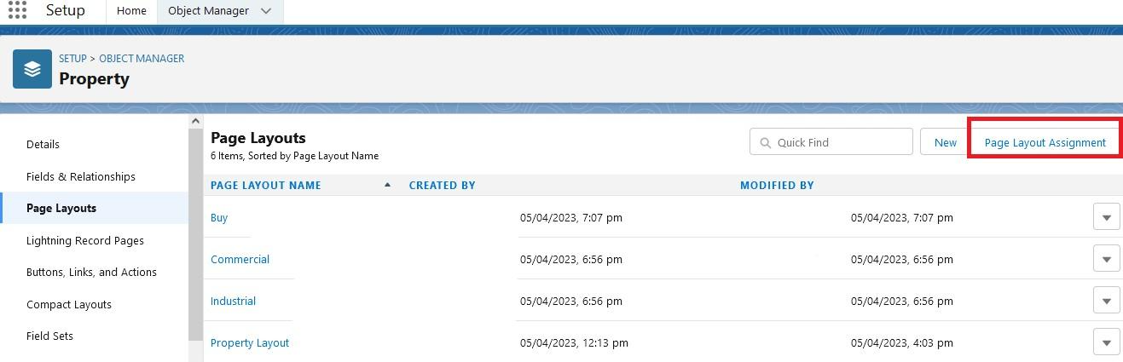

**Page Layout Assignment For Rent**

Follow above 1 to 3 steps  
We assign rent page layout for rent record type.

**Profile**

1. A profile is a group/collection of settings and permissions that define what a user can do in salesforce.
2. Profile controls “Object permissions, Field permissions, User permissions, Tab settings, App settings, Apex class access, Visualforce page access, Page layouts, Record Types, Login hours & Login IP ranges.
3. You can define profiles by the user's job function. For example System Administrator, Developer, Sales Representative.

Types of profiles in salesforce   
Standard profiles:

1. By default salesforce provide below standard profiles.
2. We cannot deleted standard ones
3. .Each of these standard one includes a default set of permissions for all of the standard objects available on the platform.

Custom Profiles:

Custom ones defined by us.  
They can be deleted if there are no users assigned with that particular one.

**Create A New Profile**

To create a new profile:

Go to setup ? type profiles in quick find box ? click on profiles ? clone the desired profile (standard user is preferable).

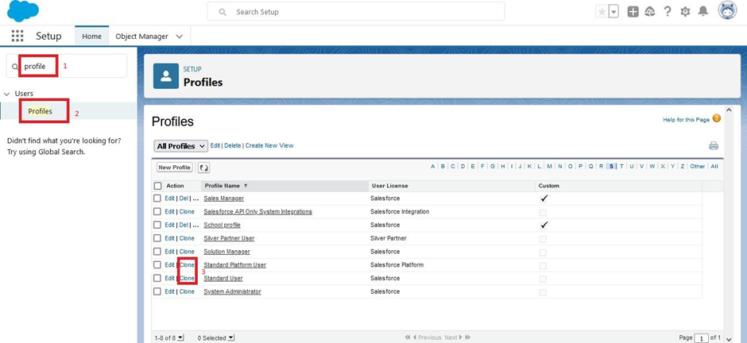  
  
  
Enter a Profile Name(Sales Manager) And click on Save  
  
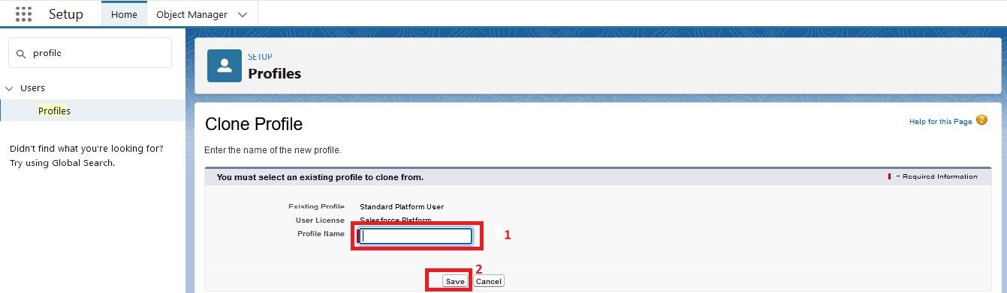  
  
  
  
  
Click on the new created profile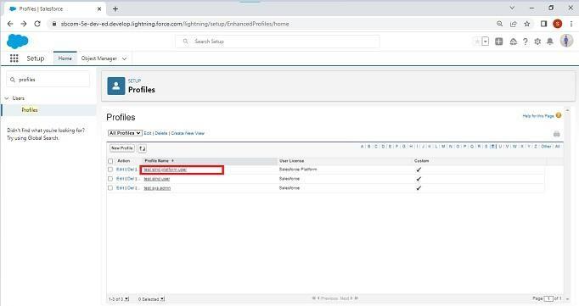  
  
  
  
While still on the profile page, then click Edit.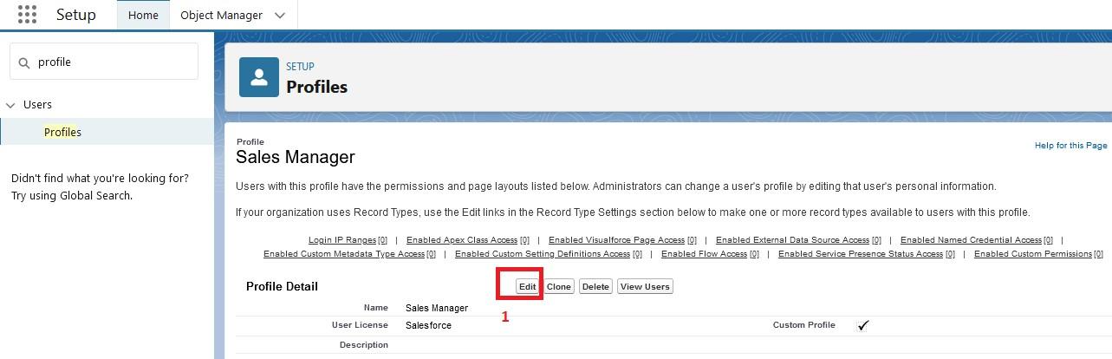  
  
  
Scroll down to Custom Object Permissions and Give view all access permissions for Lead, Property, Loan and save(Sales Manager also Having Create, Edit, Delete for Lead, property, loan objects)  
  
  
  
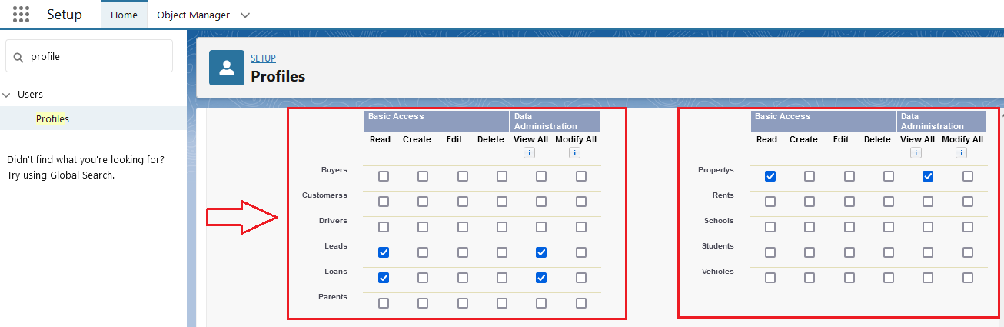

6.Create Remaining Profiles

Follow the Above Steps to create the Profile just change the Name for below profiles Clone profile (Standard Platform User) for below all profiles

(a). Marketing Executive profile (b). Marketing Manager profile

**Create Marketing Executive Profile**

Create Marketing Executive Profile

1.Then In The Profile Level Give Read and Create Access for Lead, property, loan objects to Marketing Executive profile and Read, Create, Edit, Delete for the Marketing manager profile for Lead, property, loan objects  
2.Marketing Manager profile Should Have Access to Marketing Executive profile

**Create Sales Executive Profile**

Activity3- Create Sales Executive Profile:  
 Follow the Above Steps to create the Profile just change the Name for Below profiles clone profile (StandardPlatform User) ,profile name (Sales executive profile).  
And assign a sales rep1 permission set  
For Sales Rep1? Read, Create, Edit for lead, property and loan objects. For Sales Rep3? Read only.  
  
Note: above 2 are permission set and assign a permission set according to user need. We will discuss in next milestone.

**User**

* A user is anyone who logs in to Salesforce. Users are employees at your company, such as sales reps, managers, and IT specialists, who need access to the company's records.

* Every user in Salesforce has a user account. The user account identifies the user, and the user account settings determine what features and records the user can access.

**NOTE**- As Salesforce license can only be used by 2 Users at a time in Dev Org,so If you don’t find salesforce license then deactivate a user who has salesforce license Or change the license type from Salesforce to any other.

**Create User**

1. Go to setup ? type users in quick find box ? select users ? click New user.  
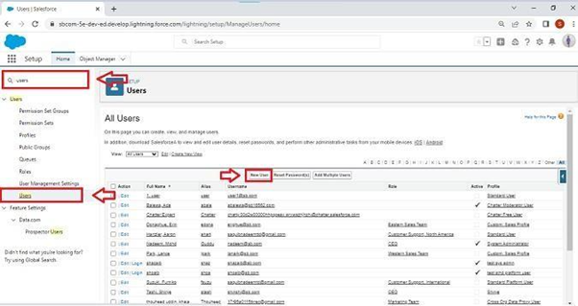  
  
First Name: Sunny  
Last Name: Gupta  
Alias: Sanj  
Email: provide your personal email id for future reference  
Username: sunnygupta@thesmartbridge.com  
  
Nickname: Sunny  
Role: leave it as default  
User License: Salesforce  
Profile: Sales Manager and Click Save Button.  
  
Note: Assign Profile according to user requirement.  
